Exercise Solution

1) Difference between .model small and .stack 100h

.model small
- This is a memory model directive in x86 assembly, commonly used with MS-DOS programs.
- In the small memory model, both code and data segments fit within a single 64KB segment each.
Code segment: The program’s executable instructions.
Data segment: The program’s data (variables, arrays, etc.).
- It's suitable for programs where the code and data are not too large.
- In this model, a near pointer (16-bit) is used for both code and data, reducing overhead and simplifying addressing within the 64KB limit.

.stack 100h
- This is a stack segment directive that specifies the size of the stack for the program.
- 100h (hexadecimal) equals 256 bytes.
- The stack is used for function calls, local variables, and handling interrupts.
- This directive reserves 256 bytes for the stack, meaning the program can push data (e.g., registers, return addresses) onto this space.

2) What is the function of int 21h?

The `INT 21h` interrupt in x86 assembly language is used to access DOS (Disk Operating System) services. It provides a wide range of functions, including file handling, input/output operations, and memory management. By setting the appropriate value in the `AH` register before calling `INT 21h`, a programmer can perform tasks such as reading keyboard input, displaying text on the screen, or manipulating files. This interrupt was a crucial part of DOS programming, allowing developers to interact directly with the operating system.

3) How does the program convert ASCII to numeric values and vice versa?

1. Converting ASCII to Numeric: When converting an ASCII character (like '5') to its numeric value (integer 5), you can subtract the ASCII value of '0' (which is 48 in decimal) from the character.

char ch = '5';

int num = ch - '0'; // num will be 5

2. Converting Numeric to ASCII: To convert a numeric value (like 5) to its ASCII character

(like '5'), you can add the ASCII value of '0' (48) to the integer.

int num = 5;

char ch = num + '0'; // ch will be '5'

4) What is the purpose of mov ah, 01h and mov ah, 02h?

In x86 assembly language, particularly when working with DOS interrupts, the instructions `MOV AH, 01h` and `MOV AH, 02h` set up different input/output functions using the `INT 21h` interrupt:
- MOV AH, 01h: This function waits for a key press and reads a single character from the keyboard. The character is returned in the `AL` register, and the program pauses until a key is pressed.
- MOV AH, 02h: This function displays a single character on the screen. The character to be displayed must be loaded into the `DL` register before calling `INT 21h`.

5) Explain the difference between mov dl, 10 and mov dl, 13.

In x86 assembly language, particularly when dealing with character I/O using `INT 21h`, the values `10` and `13` have specific meanings related to ASCII control characters:
- MOV DL, 10` (ASCII Line Feed, LF): The value `10` (0x0A in hexadecimal) corresponds to the Line Feed (LF) control character. When used, it moves the cursor down to the next line without returning to the beginning of the line. In other words, it advances the text output to a new line but keeps it aligned vertically.
- MOV DL, 13` (ASCII Carriage Return, CR): The value `13` (0x0D in hexadecimal) corresponds to the Carriage Return (CR) control character. This moves the cursor back to the beginning of the current line, but it does not move it down to the next line. It is typically used in combination with LF to start a new line.
When printing text, using both `CR` (13) and `LF` (10) (`MOV DL, 13` followed by `MOV DL, 10`) ensures the cursor moves to the start of the next line, which is how a new line is typically handled in DOS and many other systems.

6) Write a short note on the importance of register usage in assembly language programming.

. Register usage is crucial in assembly language programming because registers are the fastest storage locations available to a CPU. Efficient use of registers can greatly improve the speed and performance of a program. Registers are used for various purposes, such as holding temporary data, performing arithmetic and logical operations, addressing memory, and managing control flow. Each register has specific roles (e.g., `AX`, `BX`, `CX`, `DX` in x86) that can influence how instructions execute. By strategically utilizing registers, programmers can minimize memory access, reduce instruction cycles, and optimize program execution, making efficient register management a key skill in low-level programming.

Additional Questions

1. Modify the program to accept multi-digit numbers.
3. Display error messages for invalid inputs.
2. Implement subtraction, multiplication, and division operations.

ADDITION

INPUT: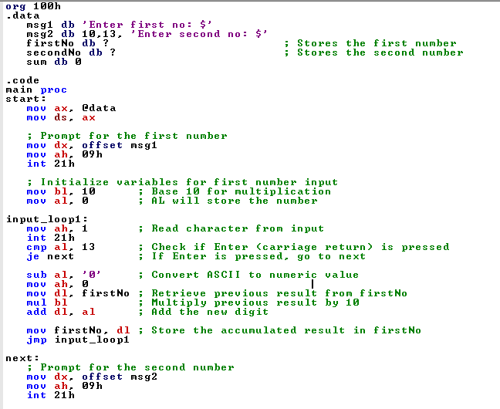


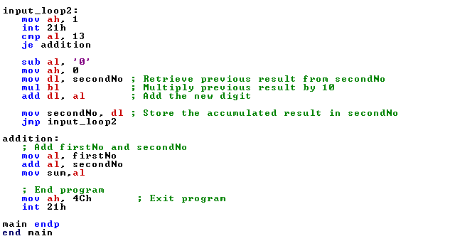

OUTPUT:

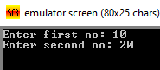
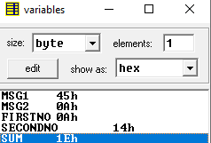

SUBTRACTION:

INPUT:
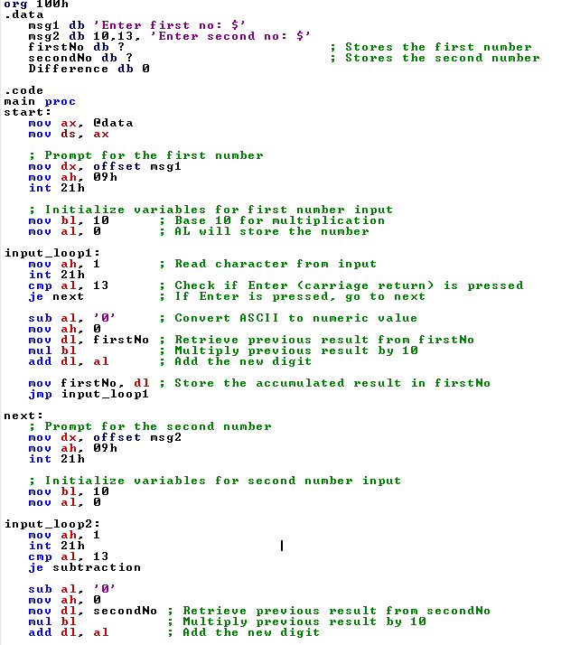

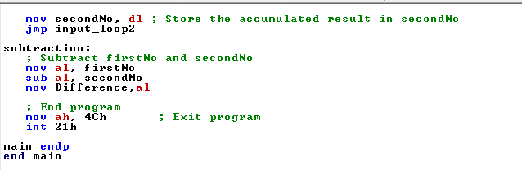

OUTPUT:
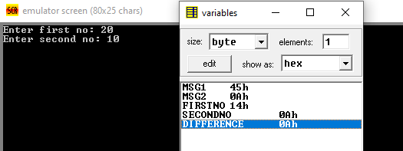

MULTIPLICATION:

INPUT:

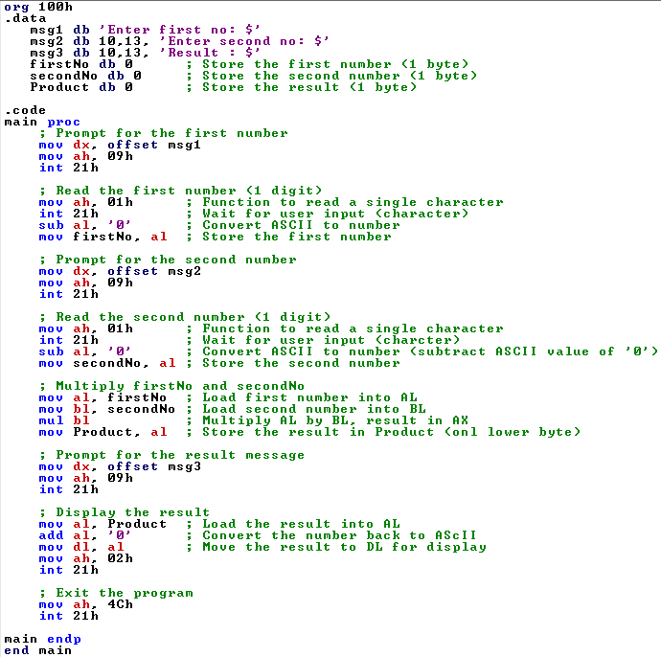

OUTPUT:

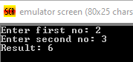

DIVISION:

INPUT:

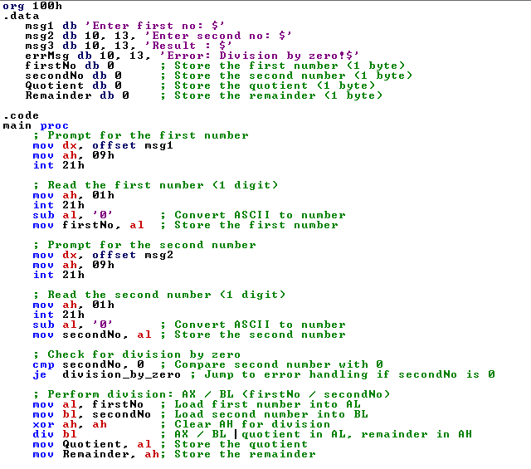
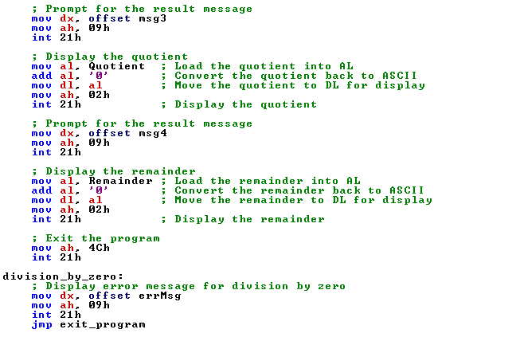

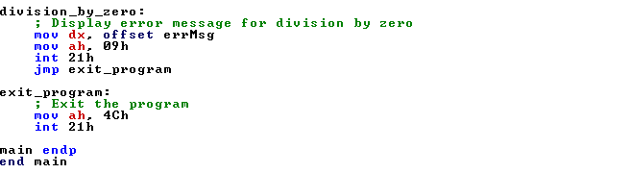

OUTPUT:
